Problem 4 – 3D Lines
You are given a rectangular cuboid of size W (width), H (height) and D (depth) consisting of W * H * D cubes, each colored in some color. Each color is denoted by a unique capital letter from the Latin alphabet: 'Y' is yellow, 'R' is red, 'B' is blue, 'G' green, etc.
Two cubes are neighbors when they share a common side, common edge or common point. A 3D line is a sequence of neighbor cubes in the same color staying on the same horizontal, vertical, or diagonal in the cuboid. At the figure below few examples of 3D lines are shown:
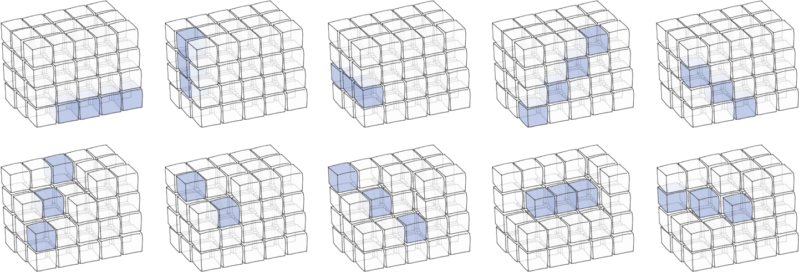
Your task is to write a program that finds the length of the longest 3D line and how many 3D lines with this length exist in the cuboid.

Input
The input data should be read from the console. At the first line 3 integers W, H and D are given separated by a space. These numbers specify the width, height and depth of the cuboid. The colors of the cubes in the cuboid are given as D sequences of exactly W letters in the next H lines. Each sequence of W letters is separated from the next one with a single space.
The input data will be correct and there is no need to check it explicitly.

Output
The output data should be printed on the console.
In the first line of the output print the length of the longest 3D line in the cuboid followed by a space and how many 3D lines with this length exist in the cuboid. If no lines exist in the cuboid print "-1" at the first line of the output.

Constraints
- The numbers W, H and D are all integers in the range [1…50].
- The letter sequence in the input consists of capital Latin latters only
- Allowed work time for your program: 0.3 seconds.
- Allowed memory: 32 MB.

Examples
Input | Output |  | Input | Output
4 3 5  AAAA AAAA ABAA AAAB AABA  AAAA BBBA AABA AABA ABAA  BBBB ABBB ABBB ABAB BBAA | 5 3 |  | 7 4 3  BRYYYYY RYYYYGY YRYYYYY  YYYGBGY YYYYGGG YYYGGGY  RBBBBBY RYYYYGY RYBYGBB  RYBYGYY RBYYGYY RRRRRYB | 5 4

Input | Output |  | Input | Output
2 2 2  AB EF  CD GH | -1 |  | 3 3 3  AAD AXD BXD  AXX XAX BXA  CCC XXA BAA | 3 7

